**From sand to silicon.**

You are about to experience a fascinating journey through the clean rooms of the semiconductor industry. See integrated circuits in the making, at one of Global Foundries chip factories.

Let our experts walk you through the nanocosmos of the atom, a world that normally remains hidden from our eyes.

In the beginning it’s the (1)………………**.** At **design** centers around the globe experts collaborate to design circuit diagrams, sophisticated integrated circuits like microprocessors, high graphic processors and wireless communications.

The next step is **manufacturing**.

The disc substrates for the micro-chips are made from courts sand and are called (2)……………….

To make these wafers a huge monocrystal is drawn from purified silicon melt.

The result is a perfect silicon lattice into which the transistors will later be fitted. However impurities pose a threat to these flawless silicon crystals.

Our Global Foundries manufacturing teams must therefore take extensive precautions every time they enter our dust-free (3) ……………. The result: our wafers are fabricated in an environment that is more than 100,000 times cleaner than an operating theatre.

Completely free of dust, the silicon discs arrive at the clean room.

Here 25 wafers are packed into each hermetically sealed container and sent off on a journey that will take them through hundreds of manufacturing steps.

(4)…………………. techniques transfer the circuit structures to the wafers rather like slide projection.

The key to this whole process is a solid mastery of light.

The silicon disk is spin coated with a photosensitive resist.

UV light transfers the circuit structure is depicted on a (5)……………..to the wafer.

The exposed parts of the resist are soluble and removed by a developer.

The transferred structures can now be used as a template.

The unprotected parts of the wafer surface are (6)………………..away.

The structures of billions of small current switches are generated on each wafer, tiny transistors

From the photolithographic stage, wafers move on to the (7)………………………………….where the electrical properties of the transistors will be specified.

Here the engineers make good use of one of silicones most important properties: silicon is a (8)…………………., which means that its conductivity can change by a high precision emplacement of so-called (9)………………………….

First, dopant atoms are injected into the silicon structures. These atoms then distribute randomly in the silicon lattice.

At high (10)………………..the doping atoms become flexible and take on a fixed position in the atomic structure.

The complexity of manufacturing tiny transistors requires a clean room as big as two soccer pitches.

While our people monitor the complex processes, automated manufacturing itself always takes place within hermetically sealed production lines.

Copper dominates the next process step: the finest (11)………………………..wires link up billions of separate transistors to form integrated circuits.

Before that can happen, however, cleaning is essential for wafers, as particles lurk at every stage in the manufacturing process.

Before the copper is poured into the trenches for the interconnects, a barrier layer is applied.

It helps to avoid short circuits and guarantees reliability.

The trenches are then filled with (12)……………….. .

Finally the excess copper is ground down to the edges of the trenches, this insulates each interconnect from the others.

A microchip made of copper wiring established Global Foundries as the first company in the world to adopt copper in volume production, a foundation for the state of the art multi-core processors that Global Foundries is introducing today in all product areas.

To keep us on the leading edge of the world's chipmakers (13)…………………………….constantly monitor every step in the manufacturing process, down to the atomic structures of each individual transistor.

In two months the wafer is ready.

Huge integrated circuits consisting of conductors with a length of multiple kilometers link up 100 billion transistors on numerous levels. And that in a space no larger than a (14)………………...

Global Foundries, the first truly global semiconductor foundry, located in the USA and Germany, have one fab in Dresden and the future fab in New York.

Together they'll be two of the most advanced chip factories on earth and a testing ground for the very latest microelectronic innovations from around the globe.

The last production step in microprocessor manufacturing is the (15)……………………….of the chips.

In preparation for this step in silver pellets are applied on the wafer. They will link the chip to the frame. Via the finest saw blades the chips are cut off the wafer the flip-chip method is used to bond the chip to the frame which is sealed with a cover.

**Exercise:** Fill the gaps with the following terms.

*(a) electron microscopes, (b) mask, (c) silicon wafers, (d) circuit diagram, (e) photolithographic,*

*(f) etched, (g) semiconductor, (h) dopant atoms, (i) temperatures, (l) ion implantation,*

*(m) interconnect, (n) cleanroom, (o) copper, (p) packaging, (q) fingernail.*

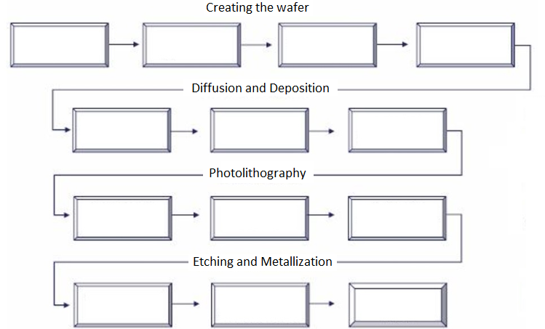

*Complete the scheme inserting the process steps in the correct order.*

1. *Slicing the silicon ingot into wafer*
2. *Depositing electrically conductive materials*
3. *Forming a layer of silicon dioxide*
4. *Depositing insulating or conducting layers*
5. *Annealing the conductive material*
6. *Forming a silicon ingot*
7. *Removing residual photoresist material*
8. *Etching circuit patterns*
9. *Lapping and polishing the silicon wafer*
10. *Diffusing dopant*
11. *Creating circuit patterns*
12. *Cleaning the wafer*
13. *Coating and baking photoresist material*

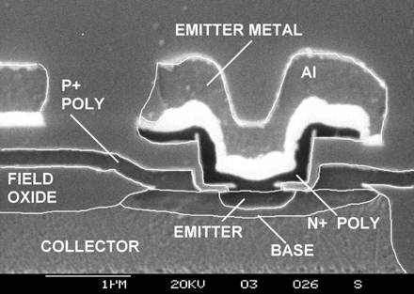

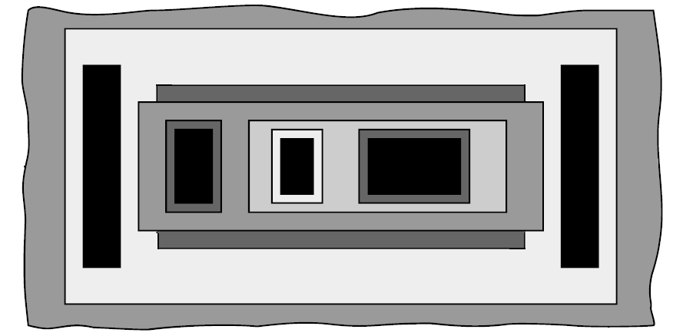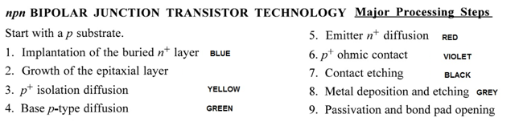

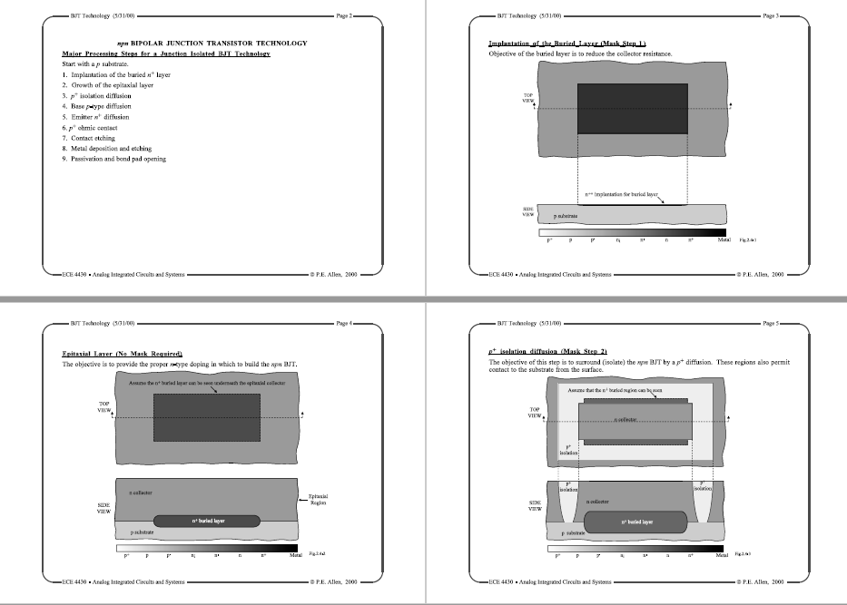

**Exercise:** Create on the tracing paper the masks with the necessary patterns

